**The tomato ripening**

Tomatoes ***give off*** minute quantities of ethylene gas

which is active in the starting the natural ripening process.

It left to nature, however, that the tomatoes ripen in a random way.

The **trickled** ethylene gas process of tomato ripening consists of exposing tomatoes to a low concentration

of ethylene gas, under controlled temperature conditions in a special tomato-ripening room.

This trickle initiates, and controls the speed of the natural ripening, and coloring process in the tomatoes.

Controlled ripening and coloring enables the grower to market tomatoes of more uniform color

and quality than is possible with green or field-ripened produce.

Timing of harvesting and marketing may, within limits, also be regulated by the use of

controlled ripening and coloring, in order to achieve maximum returns and the best use

of labour and equipment.

**Ripening Conditions**

All fruit must be mature green at harvest for controlled ripening to be successfully carried out.

Relative humidity does not appear to be great importance in the tomato-ripening process.

Little moisture loss from the tomatoes occurs during the ripening process

due to the relatively **impermeable** nature of the tomato skin.

Ripening time will depend on the ripening temperature range; however, ripening temperatures

above 24 Celsius degree will result in poor color development with yellow or orange fruit rather than red.

***Heating and cooling capacity*** should be such that the tomatoes can be brought to

the recommended ripening temperature within 24 hours.

**The general arrangement**

A typical arrangement for a tomato ripening room is shown in the figure

along with the essential components of the system identified.

**Room size and Construction**

For the efficiency and convenience in operation, on-farm tomato ripening rooms are

usually sized to accommodate the normal daily tomato pick during the peak harvest time.

Room capacity is generally in range of two to ten tones of tomatoes. However,

larger rooms may be sometimes be installed.

**Air Circulation and Ventilation System**

Fan-forced air circulation is required for adequate and uniform temperature control

and ethylene gas distribution in the ripening room. An air circulation rate of two-room air volumes one minute

is recommended for good results, equivalent to roughly 480 cubic meters of air per hour each ton of tomatoes.

At the recommended heating or cooling capacity of 0.6 to 1.2 kw per ton of tomatoes, this gives

an air temperature differential of 3.5 to 7 Celsius degree across the heating and or cooling system.

And these high air circulation rates, of course, are crucial to restrict variations in temperature

of different parts of room to the acceptable levels and to gain an sufficient rate of heating or cooling

amongst the tomatoes.

Ventilation system circulates room air continuously, introducing a small proportion of air

and exhausting a similar amount of air at same time (so called concurrently)..

This prevents a **build up** of ethylene gas in room, as well as removes carbon dioxide produced by fruit

during **respiration**. As this carbon dioxide were allowed to build up too high a level in room air, it would then

interfere with the ripening process.

**Temperature Control System**

The temperature of tomatoes in the ripening room has a great impact on ripening process.

In fact, the product heat load usually represents around 80% of the total heat load.

The remainder is due to heat transmission through the external walls of the room

And the fresh air exchange rate. In some cases, both heating and cooling are needed to maintain

the room temperature within required rate. The time required for ripening can be reduced

to some extent by increasing the temperature. Reverse cycle air-conditioners are successfully used

for both heating and cooing in tomato ripening rooms where humidity control does not show

to be a great importance in fact.

**Supply and Control System**

With the trickled ethylene gas system, a low concentration of ethylene gas is kept in ripening room atmosphere

by a continuous small, controlled flow of gas of about 10 parts per million(ppm).

Ethylene gas is provided as bottled gas under high pressure and it is released into the ripening room

through a pressure **regulator** and **metering** system.

The **outlet** gas pressure is adjusted ***by means of*** the gas pressure regulator and the gas flow rate

is then altered by the fine **needle valve**. A normally closed **solenoid** **valve** in the ethylene ***gas supply line***

ensures that gas is not **discharged** into room unless fans and ventilation system in the ripening room are

running/ operating. The solenoid valve is electrically **interlocked** with the operation of ventilation system fans

and is also controlled by an air flow switch.

A gas control thermostat is used to measure when gas should be supplied to the room. The temperature-

sensing element of this thermostat is pushed into a tomato so that it senses the pulp temperature of tomatoes

in different parts of the room.

Provided that the ethylene gas supply and control systems are correctly arranged, the ethylene gas

concentration in the room will not exceed the low level which is sufficient or ripening but is far below

the explosion hazard level. Under these conditions, tomato-ripening rooms installed on farms and used

only for ripening fruit produced by the owner have been approved by certain Electricity Commissions

as not constituting a hazardous location.

**Glossary**

**Give off:** release/produce heat/ smell

**Trickle:** to make things slow down

**Impermeable:** unable to let liquid pass through (*synonym: water-proof*)

**Ventilation**: the act of allowing the air to enter and move through

**Regulator:** a device for controlling the level or amount of something (such as speed or temperature),

in this case pressure.

**Metering:** an instrument for automatically measuring and recording quantity (of gas, .etc.)

**Outlet:** a way hole for gas or liquid to come out (pipe)

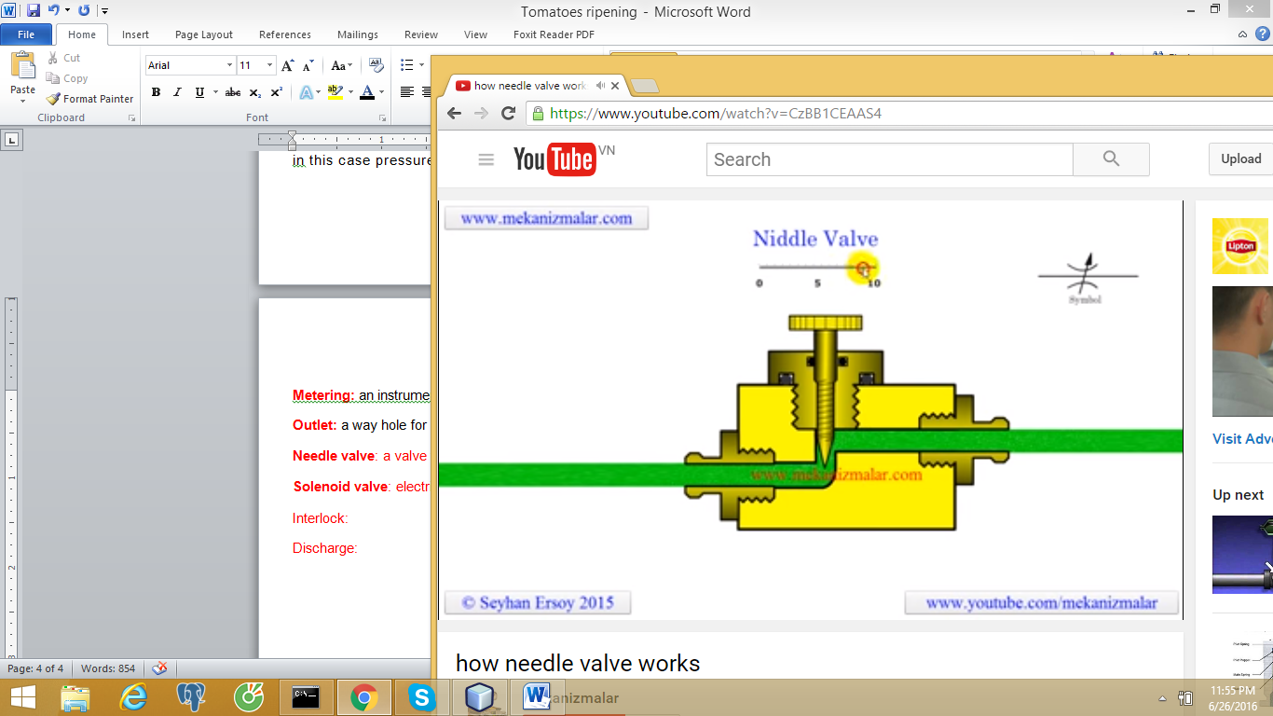**Needle valve**: for precise and slow flow of gas, or liquid.

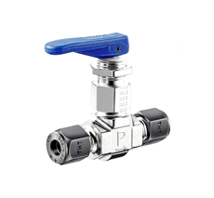

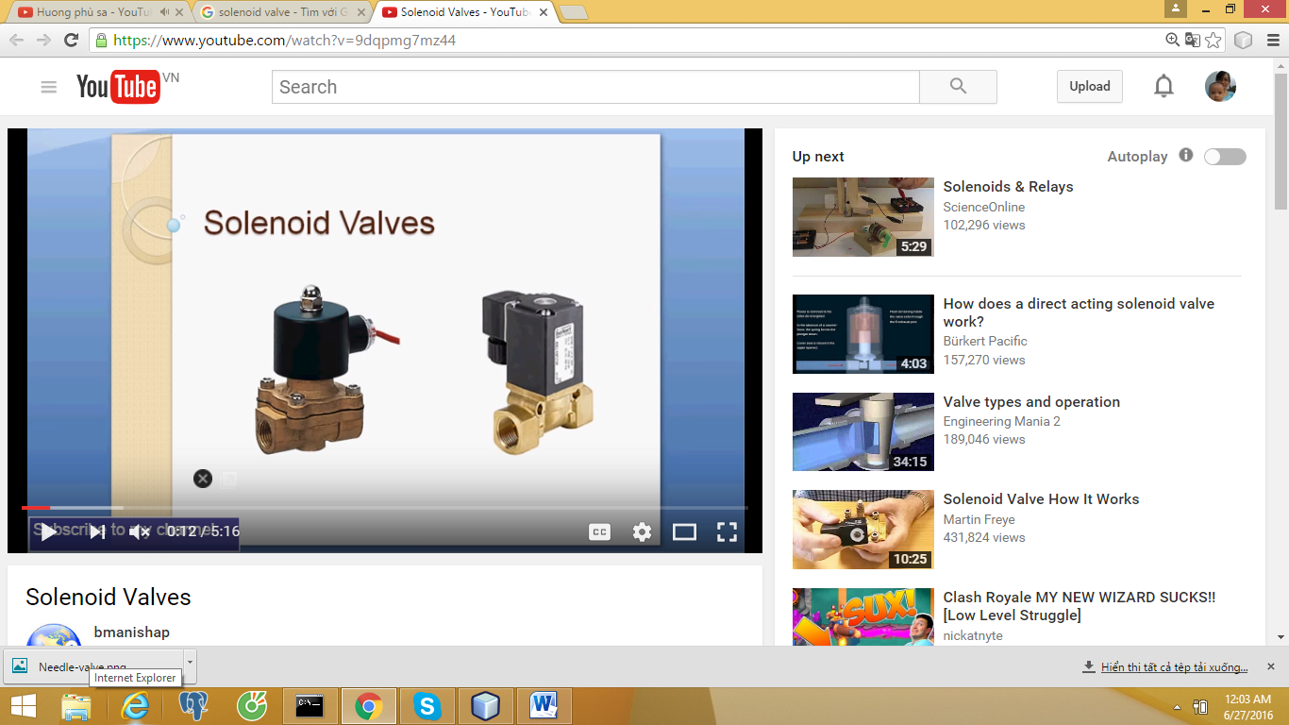

**Solenoid valve**: electrical valve

**Interlock:** fit into each other, to synchronize a machinery action

**Discharge**: relieve a flow

**Gas supply line: 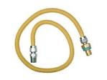Thermostat:**

**Push something into something:** shine into something

**Pulp:** inner juicy part of somewhat fruit